Flower structure 3 - Deadnettle and Lupin
stamen
filament
anther

White deadnettle (Lamium album) The
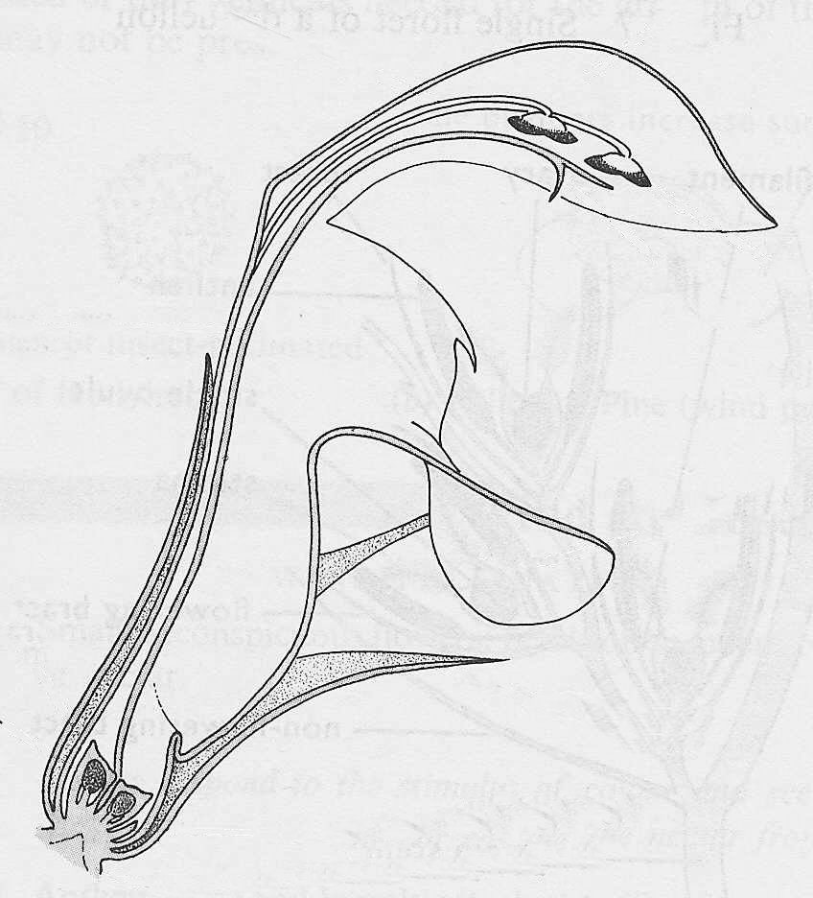
deadnettle has five ‘spiky' sepals, joined
at the base to make a cup, surrounding
a tube of five joined petals of which the
uppermost is particularly well-developed.
There are only four stamens, with their
black anthers close together under the
top petal and their filaments joined to
stigma
style
the petal tube. There is a forked stigma,
and a long style leading to a four-lobed
ovary.

ovary

sepal
Half flower of white deadnettle (Lamium album)

ovule

standard
Lupin Five joined sepals, with
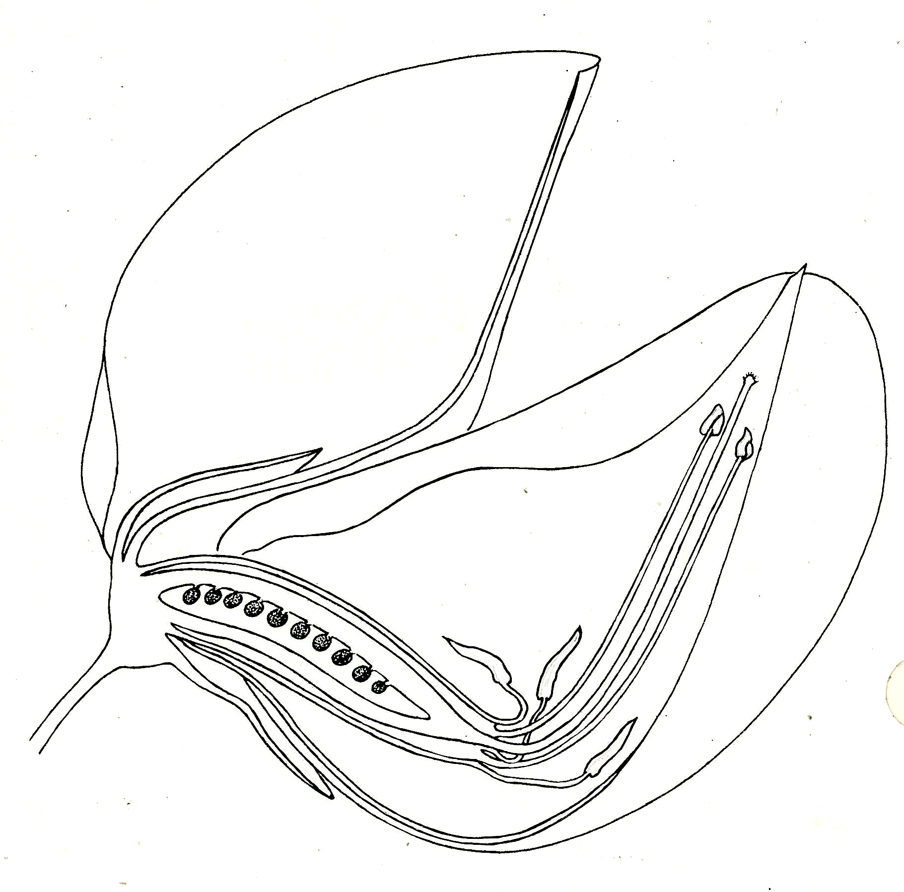
a two-lobed appearance; five
wing
petals
petals, not all joined but of
different shapes and sizes. The
keel
uppermost petal is called the
standard, and the two partly
joined petals at the side are the
wings. Within the wings are two
more, partly joined petals
stigma
forming a boat-shaped keel
Inside the keel are ten stamens
the filaments of which are joined
to form a sheath round the ovary.
The ovary is long, narrow and
pod-shaped, and consists of one
carpel with about ten ovules.
style
The style ends in a stigma, just
within the pointed end of the
ovule
keel.
anther
ovary
filament
Half flower of lupin
(Lupinus perennis)
© D.G. Mackean

